# SASMO 2016 PRIMARY 2

**TIME: 90 MINUTES**

**Section A (Correct answer = 2 marks; no answer = 0; incorrect answer = minus 1 mark)**

1. The shapes below formed a pattern. Observe carefully and find out the two missing shapes.

☼ → ☆ → ☽ → ? → ? → ☆ → ☽ → ✦ ……

A) ☼ và ☽ B) ☆ và ☽ C) ✦ và ☼

D) ✦ và ☆ E) ✦ và ☽

1. How many hours are there in two weeks?

A) 7 × 12 B) 7 × 2 × 12 C) 2 × 7 × 2 × 12

D) (7 + 7) × 12 E) None of the above

1. David takes 30 seconds to climb from the first floor to the third floor. How many seconds does he takes to climb from the third floor to the sixth floor?

A) 30 seconds B) 35 seconds C) 40 seconds D) 45 seconds E) 50 seconds

1. What is the next number in the sequence below?

A) 4 B) 11 C) 14

D) 15 E) None of the above

1. 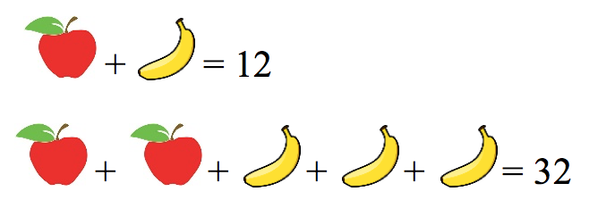

What number does stands for?

A) 2 B) 4 C) 6 D) 8 E) 10

1. Uncle John has a farm. His wife and his two sons are staying with him in the farm. They raise 10 cows and 20 chickens. How many legs are there in total in the farm altogether?

A) 60 B) 80 C) 86 D) 88 E) 120

1. It takes 5 minutes to boil an egg. What is the least amount of time it takes to boil 3 eggs?

A) 8 minutes B) 12 minutes C) 15 minutes

D) 18 minutes E) None of the above

1. The diagram shows some cubes of the same size stacked at a corner of a room. How many cubes are there altogether? (Note: The floor is horizontal and the two walls are vertical. There are no gaps or holes behind the visible cubes.)

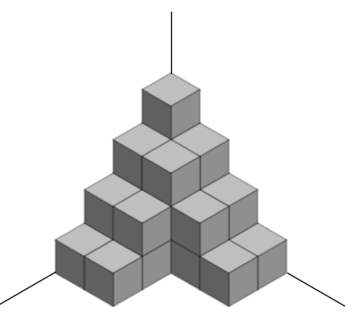

A) 24 B) 25 C) 26 D) 27 E) 28

1. Peter and the other 4 kids are having a race. If Peter overtakes the kid who is in the second place, what position is Peter in right now?

A) first B) second C) third

D) fourth E) fifth

1. There are four boxes labeled W, X, Y, and Z. W and Z are the same size. W can fit inside X, and Y can fit inside Z. Knowing this, which one of the following statements is true for certain?

A) Z cannot fit inside X.

B) X can fit inside Z*.*

C) X cannot fit inside Y.

D) W can fit inside Y*.*

E) None of them.

1. 989 individual candies are packed into packages which each contain 4 candies. In order to complete the last package, how many more candies are needed?

A) 2 B) 3 C) 4

D) 5 E) None of the above

1. Two years ago the sum of Amy’s and Bob’s ages was 8. What will the sum of their ages be after 3 years from now?

A) 11 B) 14 C) 18

D) 15 E) None of the above

1. The numbers 2, 3, 4 and 5 are filled in the figures on the below so that each line of the cross adds to the same number.

What number should be placed in the place of the question mark?



A) 2 B) 3 C) 4

D) 5 E) None of the above

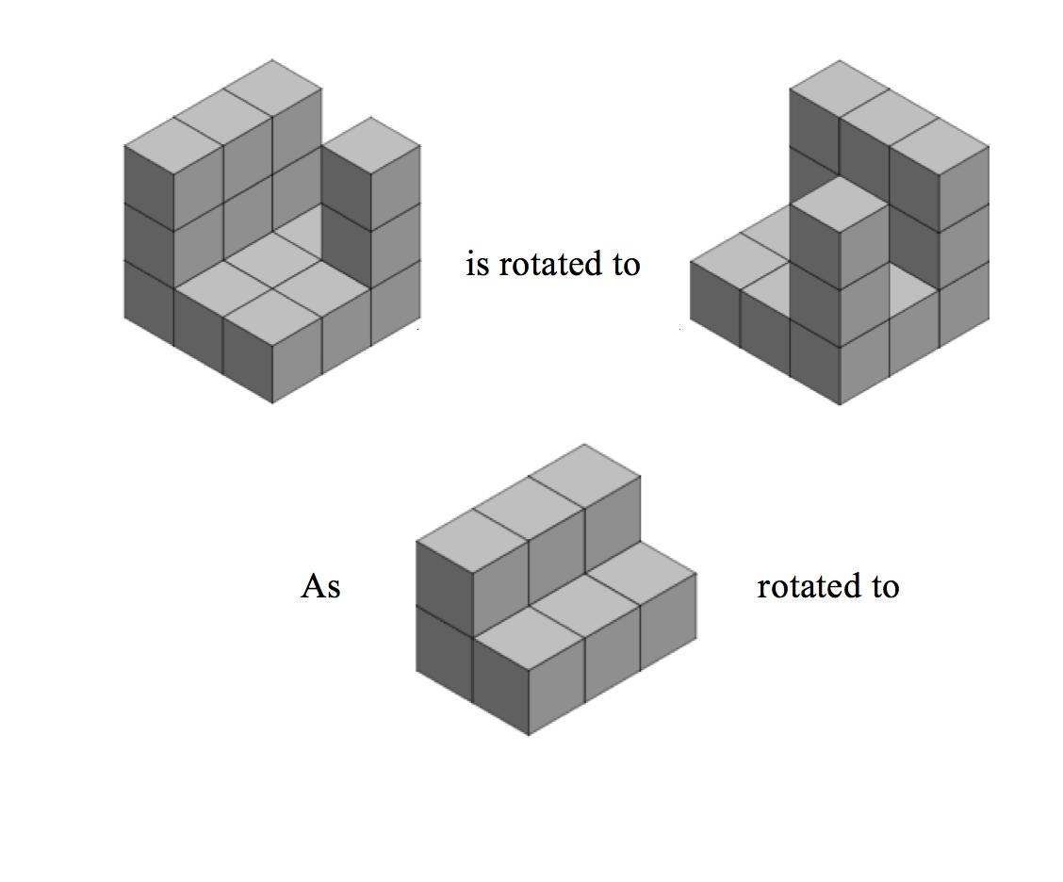

A) 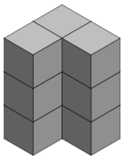 B) 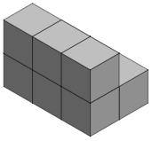

C) 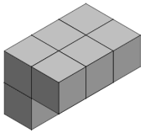 D) 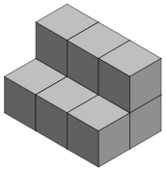

E) 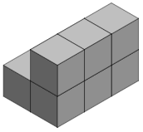

1. Which of the following cubes cannot be formed by folding the figure on the below?



A)  B) 

C)  D) 

E) None of the above

**Section B (Correct answer = 4 marks; incorrect or no answer = 0)**

1. For the number sentence below, what is the answer?
2. What is the largest 2-digit number that can be divided by both 3 and 5?
3. In a magic show, the magician placed 3 cards on the table, as shown below. Each card has a **math symbol** on one side and a **number** on other side.

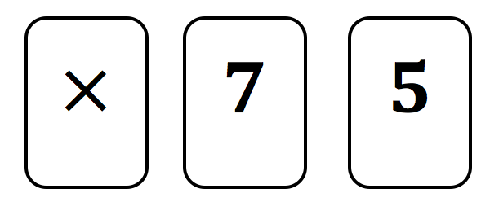

After showing the cards, he flipped over some (maybe all) of the cards and rearrange them. The new arrangement of the cards is shown below.

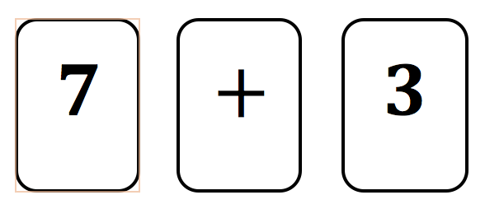

What number is on other side of the card with symbol ‘’?

1. A basket of mangoes weighs 80 grams when full and 60 grams when half full. What is the weight of the basket when it is empty?
2. Tom makes the rectangle below with 10 gumdrops and 10 toothpicks.



Afterwards, Tom makes another rectangle using 32 gumdrops. The long side of the new rectangle has twice as many gumdrops as the short side. How many gumdrops are on the short side of the new rectangle?

1. The picture graph below shows the number of pencil cases that Bob, Macy, Jane and Danny have. Each pencil case contains the same number of pencils. Altogether, they have 78 pencils. How many pencils does Danny have?

|  |  |  |  |
| --- | --- | --- | --- |
| https://encrypted-tbn2.gstatic.com/images?q=tbn:ANd9GcTEGb8LkgsPg3E-NRuOsb0QHKeB5hjPI8V6U_vtSXpxjNM_PQc6https://encrypted-tbn2.gstatic.com/images?q=tbn:ANd9GcTEGb8LkgsPg3E-NRuOsb0QHKeB5hjPI8V6U_vtSXpxjNM_PQc6  https://encrypted-tbn2.gstatic.com/images?q=tbn:ANd9GcTEGb8LkgsPg3E-NRuOsb0QHKeB5hjPI8V6U_vtSXpxjNM_PQc6https://encrypted-tbn2.gstatic.com/images?q=tbn:ANd9GcTEGb8LkgsPg3E-NRuOsb0QHKeB5hjPI8V6U_vtSXpxjNM_PQc6 | https://encrypted-tbn2.gstatic.com/images?q=tbn:ANd9GcTEGb8LkgsPg3E-NRuOsb0QHKeB5hjPI8V6U_vtSXpxjNM_PQc6 | https://encrypted-tbn2.gstatic.com/images?q=tbn:ANd9GcTEGb8LkgsPg3E-NRuOsb0QHKeB5hjPI8V6U_vtSXpxjNM_PQc6https://encrypted-tbn2.gstatic.com/images?q=tbn:ANd9GcTEGb8LkgsPg3E-NRuOsb0QHKeB5hjPI8V6U_vtSXpxjNM_PQc6 | https://encrypted-tbn2.gstatic.com/images?q=tbn:ANd9GcTEGb8LkgsPg3E-NRuOsb0QHKeB5hjPI8V6U_vtSXpxjNM_PQc6https://encrypted-tbn2.gstatic.com/images?q=tbn:ANd9GcTEGb8LkgsPg3E-NRuOsb0QHKeB5hjPI8V6U_vtSXpxjNM_PQc6https://encrypted-tbn2.gstatic.com/images?q=tbn:ANd9GcTEGb8LkgsPg3E-NRuOsb0QHKeB5hjPI8V6U_vtSXpxjNM_PQc6https://encrypted-tbn2.gstatic.com/images?q=tbn:ANd9GcTEGb8LkgsPg3E-NRuOsb0QHKeB5hjPI8V6U_vtSXpxjNM_PQc6https://encrypted-tbn2.gstatic.com/images?q=tbn:ANd9GcTEGb8LkgsPg3E-NRuOsb0QHKeB5hjPI8V6U_vtSXpxjNM_PQc6https://encrypted-tbn2.gstatic.com/images?q=tbn:ANd9GcTEGb8LkgsPg3E-NRuOsb0QHKeB5hjPI8V6U_vtSXpxjNM_PQc6 |
| **Bob** | **Macy** | **Jane** | **Danny** |

1. Tyler says to Kyle, "When I was your age, you were only 5 years old. By the time you reach my present age, I would be 44 years old" Find the present age of Kyle and Tyler.
2. How many squares are there in the figure below?



1. Dora, Lucas, Richard and Jonathan had a race. Lucas was neither the fastest nor the slowest. Jonathan was faster than Dora. Richard was slower than Lucas. Who was the fastest?
2. In the following, all the different letters stand for different digits. What is the value of C?

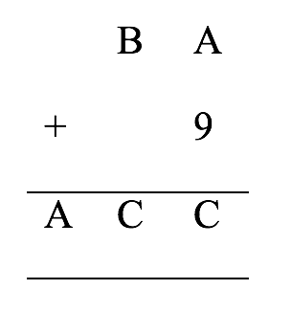

---- The end ----